Sampanuri da cqriala Rvino
CHAMPANGE & SPARKLING WINE
Teliani veli (tete de kiuvee) | naxevrad mSrali | 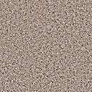 | 0.75 l. | 18.00 | lari
Teliani Valley (Tete de Cuvee) | Demi Sec |  | 0.75 L. | 18.00 | GEL
bagrationi Zveli rezervi | mSrali |  | 0.75 l. | 23.00 | lari
Bagrationi Old Reserve | brut |  | 0.75 L. | 23.00 | GEL
bagrationi | naxevrad mSrali |  | 0.75 l. | 18.00 | lari
Bagrationi | semi dry |  | 0.75 L. | 18.00 | GEL
dom perinioni | mSrali |  | 0.75 l. | 550.00 | lari
Dom Perignon | brut |  | 0.75 L. | 550.00 | GEL
moet Sandoe | mSrali |  | 0.75 l. | 250.00 | lari
Moët Chandon | brut |  | 0.75 L. | 250.00 | GEL
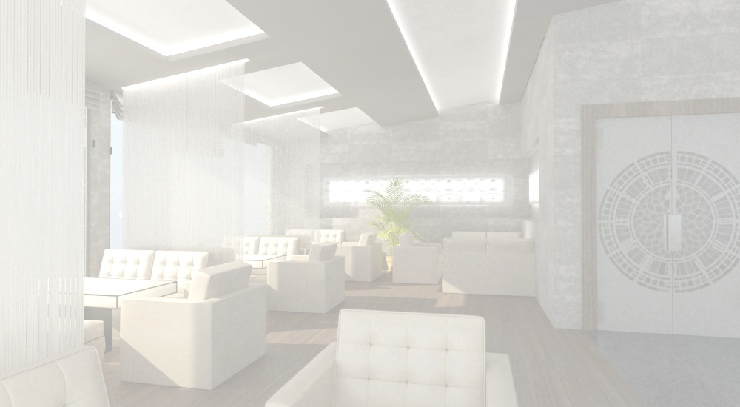  arayi premiumi |  |  |  |  |  |  |  |  |  |  |  | brendi da koniaki
Premium Vodka |  |  |  |  |  |  |  |  |  |  |  | Brandy & Cognac
absoluti |  | 0.5l. |  |  | 38.00 |  | lari |  |  |  |  |  | WaWa (Teliani veli) | 0.375l | 30.00 |  |  | lari
Abossolut |  | 0.5 L. |  |  |  |  | GEL |  |  |  |  |  | Chacha (Teliani Velley) | 0.375 L |  |  |  | GEL
finlandia |  | 0.5l. |  |  | 38.00 |  | lari |  |  |  |  |  | WaWa muxaSi daZ | 0.375l | 35.00 |  |  | lari
Finlandia |  | 0.5 L. |  |  |  |  | GEL |  |  |  |  |  | Chacha, (aged in oak) | 0.375 L |  |  |  | GEL
ruski sdantarti |  | 0.5l. |  |  | 38.00 |  | lari |  |  |  |  |  | tiflisi 3 w.daZ. | 0.5l. | 20.00 |  |  | lari
Russki Standart |  | 0.5 L. |  |  |  |  | GEL |  |  |  |  |  | TIFLIS 3 Y.O. | 0.5 L. |  |  |  | GEL
Ruskisdantarti platina |  | 0.5l. |  |  | 38.00 |  | lari |  |  |  |  |  | tiflisi 5 w.daZ. | 0.5l. | 27.00 |  |  | lari
Russki Standart Platinum |  | 0.5 L. |  |  |  |  | GEL |  |  |  |  |  | TIFLIS 5 Y.O. | 0.5 L. |  |  |  | GEL
grei gusi |  | 1.0l. |  |  | 150.00 |  | lari |  |  |  |  |  | gruzia 12 w.daZ. | 0.5l. | 62.00 |  |  | lari
Grey Goose |  | 1.0 L. |  |  |  |  | GEL |  |  |  |  |  | GRUZIA 12 Y.O. | 0.5 L. |  |  |  | GEL
staliCnaia |  | 0.7l. |  |  | 38.00 |  | lari |  |  |  |  |  | eniseli saraj. 14 w.d. | 0.7l. | 140.00 |  |  | lari
Stalichnaia |  | 0.7 L. |  |  |  |  | GEL |  |  |  |  |  | Eniseli Saraj. 14 y.o. | 0.7 L. |  |  |  | GEL
Aarayi medofi
Vodka Medoff
medofi platina |  |  | 0.5l. |  |  | 21.00 |  |  | lari
Medoff Platinum |  |  | 0.5 L. |  |  |  |  |  | GEL |  |  |  | le kavkasi 20 wliani | 0.7l. |  | 175.00 | lari
medofi oqro |  |  | 0.5l. |  |  | 21.00 |  |  | lari |  |  |  | LE CAUCASE 20 Y/O | 0.7 L. |  | 175.00 | GEL
Medoff Gold |  |  | 0.5 L. |  |  |  |  |  | GEL |  |  |  | kurvazie v.s.o.p. | 50 mg |  | 11.50 | lari
medifi originali |  |  | 0.5l. |  |  | 19.00 |  |  | lari |  |  |  | Courvoisier V.S.O.P. | 50 Mg |  | 11.50 | GEL
Medoff original |  |  | 0.5 L. |  |  |  |  |  | GEL |  |  |  | grapa gojia | 0.7l. |  | 74.50 | lari
mernaia rZeze |  |  | 0.5l. |  |  | 19.00 |  |  | lari |  |  |  | Grappa Goccia | 0.7 L. |  | 74.50 | GEL
Mernaya filtered in milk |  |  | 0.5 L. |  |  |  |  |  | GEL |  |  |  | remi martini v.s.o.p. | 50 mg |  | 15.00 | lari
mernaia(xorblis TavTaviT) |  |  | 0.5 l |  |  | 21.00 |  |  | lari |  | 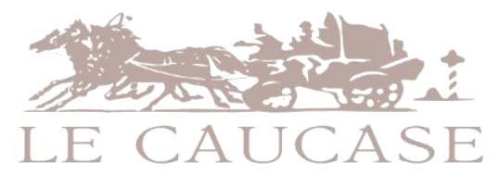 |  | 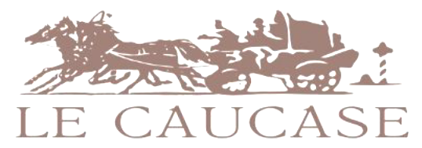  Remy Martin V.S.O.P. | 50 Mg |  | 15.00 | GEL
Mernaya (With Wheat) |  |  | 0.5 L. |  |  |  |  |  | GEL |  |  |  | remi martini X.O. | 50 mg |  | 45.00 | lari
sobieski(oqro) |  |  | 0.5 l |  |  | 27.00 |  |  | lari |  |  |  | Remy Martin X.O. | 50 Mg |  | 45.00 | GEL
SOBIESKI (Gold) |  |  | 0.5 L. |  |  |  |  |  | GEL |  |  |  | henesi v.s.o.p. | 50 mg |  | 16.00 | lari
sobieski(vercxli) |  |  | 0.5 l |  |  | 23.00 |  |  | lari |  |  |  | Hennessy V.S.O.P. | 50 Mg |  | 16.00 | GEL
SOBIESKI (Silver) |  |  | 0.5 L. |  |  |  |  |  | GEL |  |  |  | henesi X.O. | 50 mg |  | 48.00 | lari
sobieski(wiTeli) |  |  | 0.5 l |  |  | 20.00 |  |  | lari |  |  |  | Hennessy X.O. | 50 Mg |  | 48.00 | GEL
SOBIESKI (Red) |  |  | 0.5 L. |  |  |  |  |  | GEL
gamagrilebeli sasmelebi |  |  |  |  |  |  |  |  |  |  |  |  | naturaluri wveni jafa
Soft Drinks |  |  |  |  |  |  |  |  |  |  |  |  | Natural Juice Jafa
iqs_eli | 0.33l |  |  | 6.50 |  |  |  | lari |  |  |  |  | naturaluri wveni | 0.25l. |  | 2.60 | lari
XL | 0.33 L. |  |  |  |  |  |  | GEL |  |  |  |  | Natural Juice | 0.25 L. |  | 2.60 | GEL
nabeRlavi | 0.5l. |  |  | 2.00 |  |  |  | lari
Nabeglavi | 0.5 L. |  |  |  |  |  |  | GEL
borjomi | 0.5l. |  |  | 2.00 |  |  |  | lari |  |  |  |  | xilis freSi | 0.25l. |  | 7.50 | lari
Borjomi | 0.5 L. |  |  |  |  |  |  | GEL |  |  |  |  | Fresh Juice | 0.25 L. |  | 7.50 | GEL
likani | 0.5l. |  |  | 2.00 |  |  |  | lari
Likani | 0.5 L. |  |  |  |  |  |  | GEL
borjomi wyaros wyali | 0.5l. |  |  | 2.00 |  |  |  | lari
Borjomi mineral water | 0.5 L. |  |  |  |  |  |  | GEL
sodiani wyali | 0.33l |  |  | 3.00 |  |  |  | lari
Tonic water | 0.33 L. |  |  |  |  |  |  | GEL |  |  |  |  | momsaxureoba -15%
limonaTi | 0.5l. |  |  | 1.60 |  |  |  | lari |  |  |  |  | Service charge-15%
Limonade | 0.5 L. |  |  |  |  |  |  | GEL
koka-kola | 0.25l |  |  | 2.00 |  |  |  | lari
Coca-Cola | 0.25 L. |  |  |  |  |  |  | GEL

